
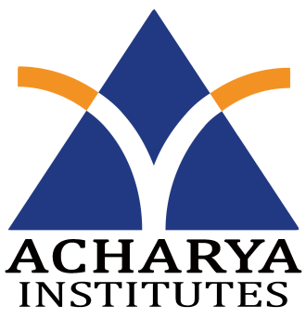
Department of Information Science and Engineering
Acharya Institute of Technology
Acharya Dr. Sarvepalli Radhakrishnan Road,
Soldevanahalli, Bangalore-560107

Date: 21/3/2016
Weekly Project Progress Report

Title of the Project: Android Based Course Delivery and Evaluation System.
Conducted at: Acharya Institute of Technology
Name and USN of the students
1. Bidish Basu, 1AY12IS021
2. Nandan A, 1AY12IS051
3. Vignesh N K, 1AY12IS096
4. Y G Sriram, 1AY12IS100
Name of the Guide: Prof. C K Marigowda
Second Week Project Progress report, Dated from 22/2/2016 to 28/2/2016

In the Second week we,
- Started working on the backend.
- Learnt about the xampp, wampp and lampp softwares.

Guide signature with Date HOD (ISE Dept.)

